concat 19 and 20 years of data

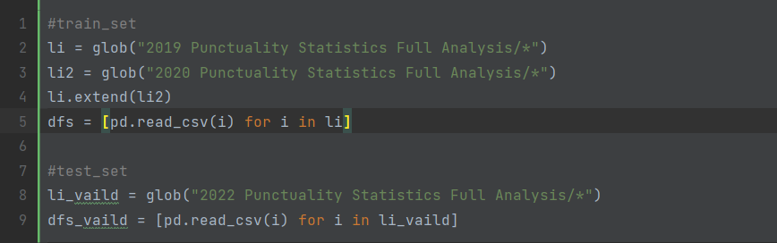

Remove private charter，remove number_flights_matched ！=0

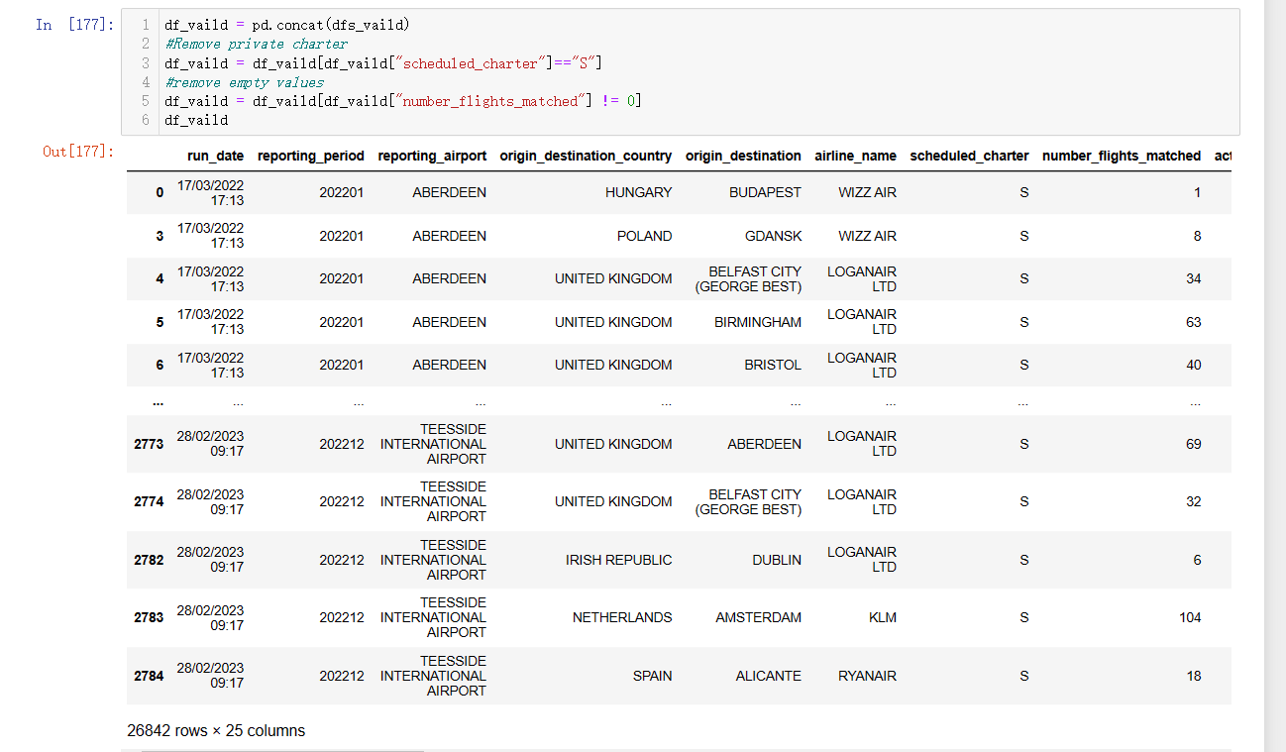

aggregation reporting_airport

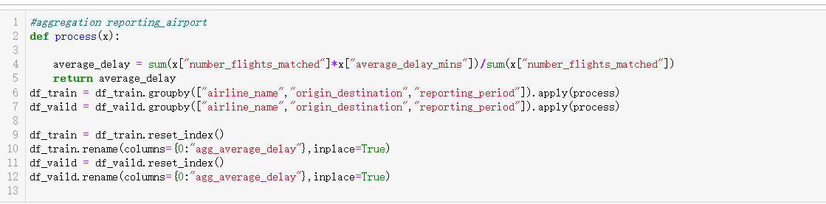



n = The number of aggregated data

Σ(number_flights_matched*average_delay_mins)/Σ(number_flights_matched)

modify reporting_period

201908 -> 1.908

Reduce data to prevent gradient explosion

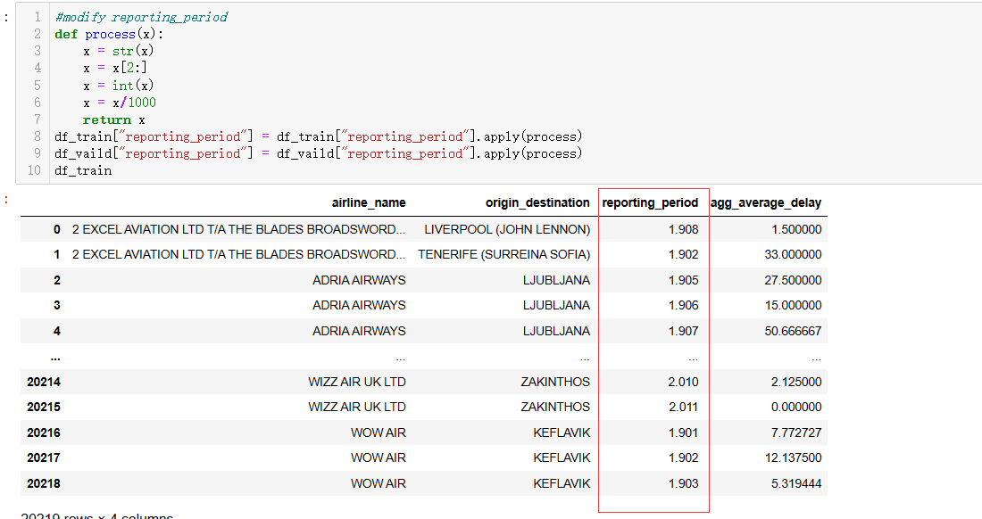

The larger the value of the heat map, the higher the correlation between the two data

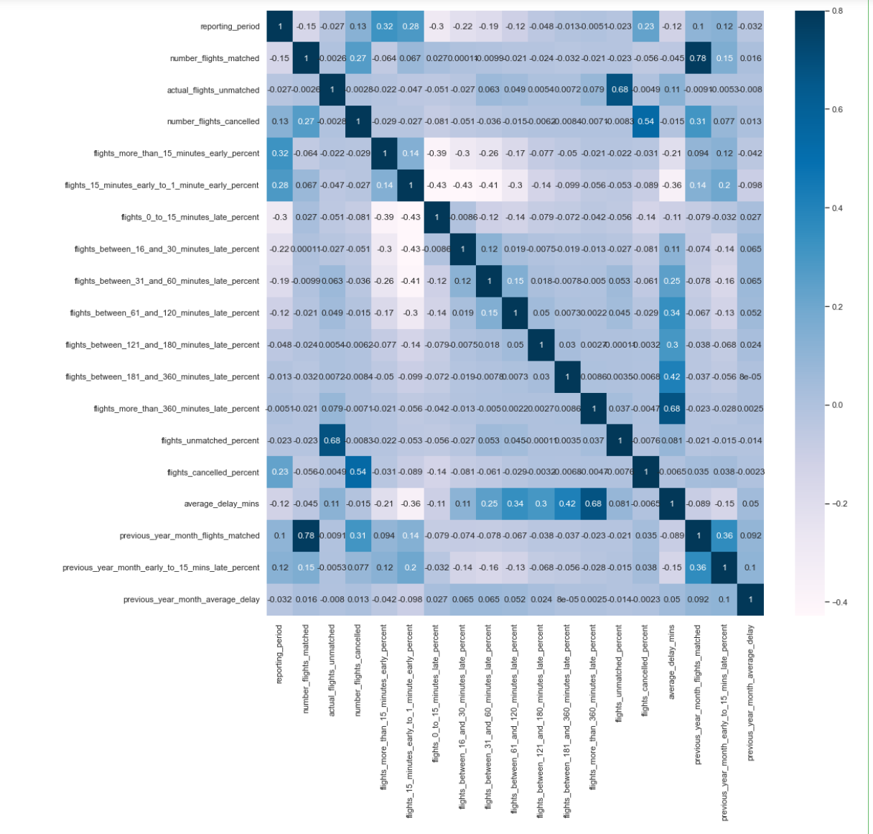

Data details, including mean, variance, min, etc.

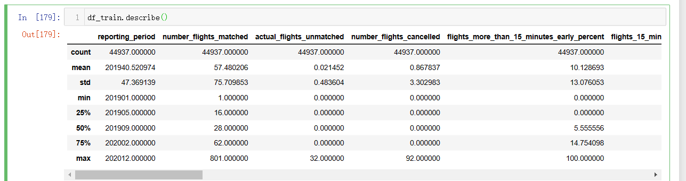

Change data astype



Split dataset

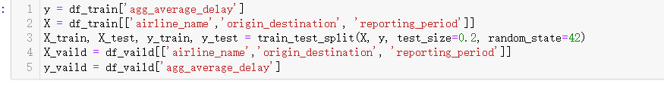

Train model use lgbmregressor

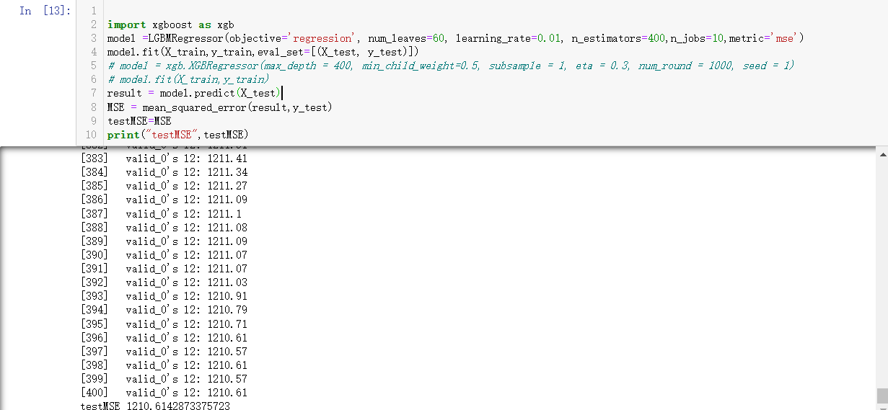

Predict 2022

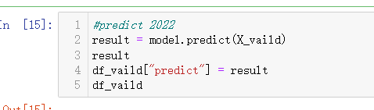

Groupby airline_name

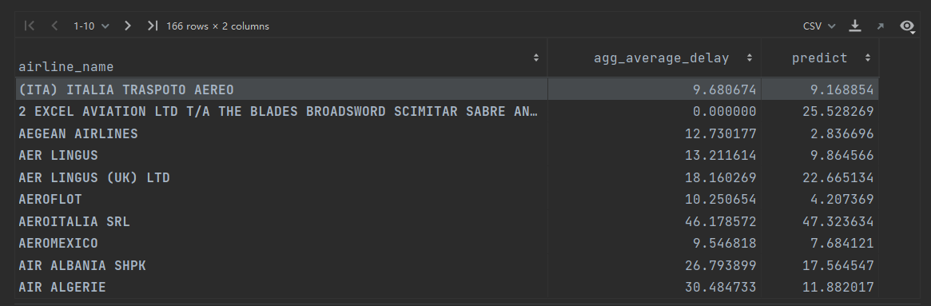

Taking the airlines as a group, calculate an average of the delay time of all months. It can be seen that some of the predicted results and the actual values are relatively close, but some of them are far apart, which may be caused by the relatively small data of some airlines.